# Section 19-2: Final Journey of the Buddha – Phase 2

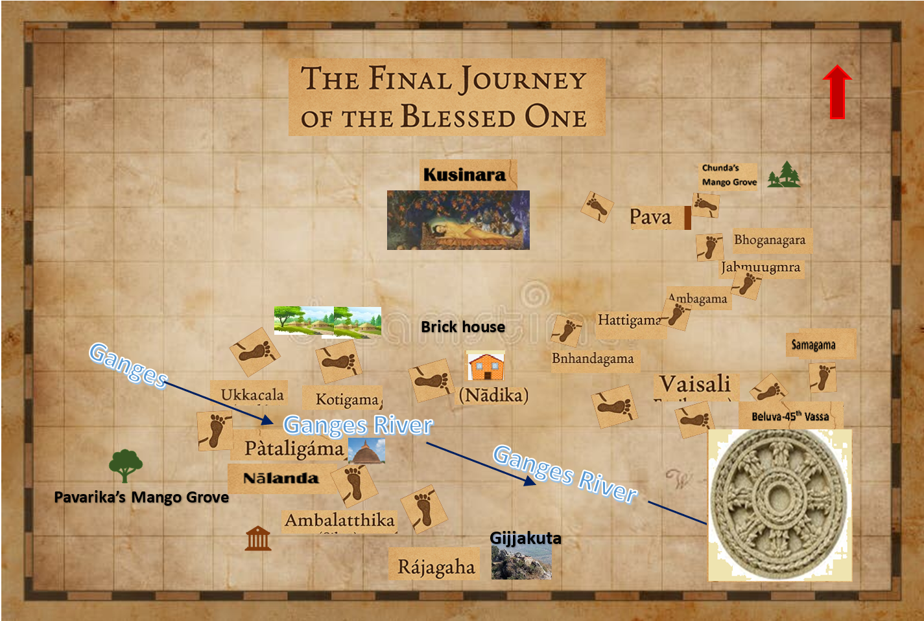

**Final Journey of the Buddha From Rājagaha to Kusinara [1]**

**1)**From **Rājagaha** to **Ambalatthika** (Silao) 7km **2)** Ambalatthika to **Nālanda** 8km **3)** Nālanda to **Pātaligama** (Patna) 82 km **4)** Pātaligama to **Ukkacala** (Hajjipur) crossing the **Ganges River** 31 km **5)** Ukkacala to **Kotigama** (also believed to be in north of Hajjipur distance unknow) **6)** Kotigama to **Nātika** or Nādika (believed to be located near in Vaishali may be 9 km ) **7)** Nādika to **Vaisali** 9 km **8)** In Vaisali Spent the Last Rains at **Beluwa** and the travelled to **Samagama** then to Vaisali from there to **Pava** (Modern day Fazilnagar in UP) 197 km (in between locations are **9)** **Bhandagama**→ **10)** **Hattigama**→**11)** **Ambagama**→**12)** **Jambugama**→ **13)Bhoganagara**→Pava) **14)** Pava (Fazilnagar) to **15)** **Kusninara** (Kusinagar) 19km the final place Od Mahāparinibbāna.

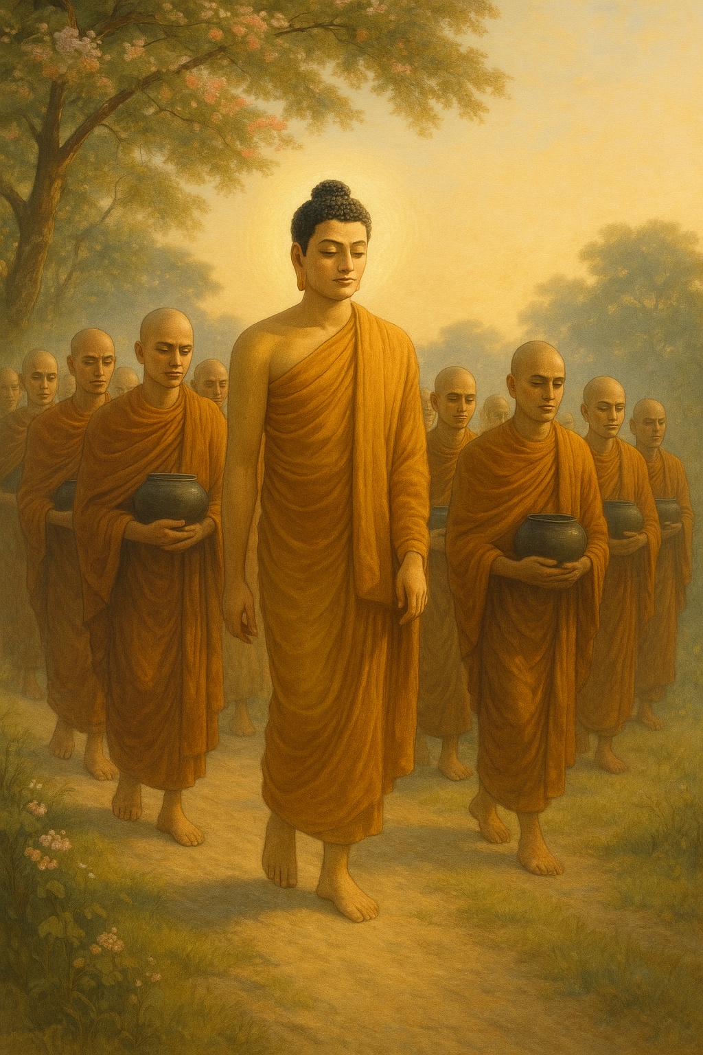

**Soft Footsteps into Silence [2]**

Beneath the gold of morning skies,  
he walks where birds no longer sing—  
not from sorrow, but from awe—  
the Buddha, still, yet journeying.

The Saṅgha follows, hearts bowed low,  
each step a teaching without word;  
the leaves lean in to feel his breath,  
the earth remembers all it heard.

He speaks of nothing left undone,  
of truths that shine through grief and flame.  
He walks not *from*, but ever *toward*,  
the deathless heart, the unbound name.

And though his body fades from view,  
his footprints press through time and dust—  
into the silence, soft and wide,  
that shelters all who love and trust.[3]

**Note:** According to scriptures in this journey the Blessed One was accompanied by his two chief disciples: Venerables: Sāriputta and Mahāmoggallana, Anuruddha, Ãnanda, Chunda and Upavana among other faithful disciples.[4]

# Section 19-2: Final Journey of the Buddha – Phase 2: Spending Time in Rājagaha

In the previous section (19-1), we followed the Blessed One and his venerable Sangha as they arrived at the serene Mango Grove of Jīvaka, nestled on the outskirts of the ancient city of Rājagaha. This marked the end of a long and purposeful journey from Sāvatthi, undertaken with steadfast resolve and boundless compassion.

According to the *Sāmaññaphala Sutta* (DN 2), the Buddha was residing in the mango grove of Jīvaka Komārabhacca, accompanied by a great assembly of monks—some twelve hundred and fifty in number. This may well have been the faithful retinue who journeyed with him from Sāvatthi, or perhaps their numbers swelled along the way, as others joined the Blessed One, inspired by his presence and drawn by the fragrance of the Dhamma he shared along the path.

In Phase 1 of this final journey, the Buddha and his disciples are believed to have walked approximately 570 kilometres (about 46 yojanas) to reach Rājagaha. Having completed his 44th vassa in Sāvatthi, it is likely that the Buddha set out on this pilgrimage around mid-November—a time traditionally chosen for long travels following the conclusion of the rains retreat.

Following the ancient rhythm of a yojana a day, it is reasonable to estimate that the journey would have taken about 46 days. Allowing for pauses to rest, teach, or offer compassion to those in need, it may have extended to nearly 12 weeks, or about 48 days. In this light, we may envision the Blessed One entering Rājagaha around mid-February, during the lunar month of Phagguṇa—a time when the land begins to warm, and the air stirs with the promise of change. Thus began the second phase of the Buddha’s final journey—a sacred pause in the holy city of Rājagaha, where many teachings had been given and where his presence would once again grace the hearts of devotees and seekers alike.

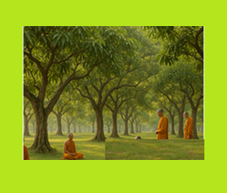

**Jeevaka’s Mango Grove in ancient Rājagaha [5]**

## **Moving from Jīvaka’s Mango Grove to Vulture Peak in Rājagaha**

Having arrived in Rājagaha, the Blessed One and the venerable Sangha initially stayed at the peaceful mango grove of Jīvaka Komārabhacca—known in the tradition as *Jīvakarāma Vihāra*. This sacred grove, located just outside the bustling city of Rājagaha (modern-day Rajgir), held a special place in the Buddha’s journey. It was here, on an earlier occasion, that Jīvaka, the devoted royal physician and benefactor of the Sangha, built a monastery within his grove and offered it to the Blessed One with heartfelt faith.

### Scriptural References to Jīvaka’s Mango Grove

The monastery built by Jīvaka is mentioned repeatedly throughout the Pāli Canon, highlighting its significance in the Buddha’s ministry:

* **MN 55 – Jīvaka Sutta**: In response to Jīvaka’s inquiry, the Buddha compassionately clarifies the discipline regarding meat consumption, teaching that monastics must refrain from eating meat when they know, suspect, or have seen that an animal was killed specifically for them. He also defends the Sangha against unfair criticism, embodying wisdom and kindness.
* **DN 2 – Sāmaññaphala Sutta**: As previously noted, this sutta locates the Buddha at Jīvaka’s mango grove when King Ajātasattu visits to learn about the fruits of the monastic life.
* **AN 8.26 – Jīvaka Sutta:** The Buddha outlines the noble qualities of a lay follower, addressing Jīvaka with deep regard.
* **SN 35.160–161 –** Jīvaka’s Mango Grove Suttas: Within this serene setting, the Buddha exhorts the bhikkhus to cultivate *samādhi*—concentration—as the gateway to seeing things as they truly are.
* **Vinaya Pitaka (Bu Ss 8 & Khandhaka 14**): These texts affirm that Jīvaka’s mango grove was one of the designated residences for monks who arrived in Rājagaha, with the Venerable Dabba Mallaputta serving as the assigner of lodgings.

## **Solitary Ascent to Vulture Peak**

Not long after his stay at Jīvaka’s grove, the Buddha is said to have ascended to the quietude of *Vulture Peak* (*Gijjhakūṭa*), a rocky promontory rising gracefully to about 400 meters above the valley floor. [6] The *Mahāparinibbāna Sutta* (DN 16) opens with the Buddha residing on this very mountain, where the winds are cool, the forests whisper, and the stillness invites deep contemplation.

Vulture Peak—also known as *Gridhrakūṭa*—lies just beyond the city’s edge, offering a vantage point both physical and spiritual. From this sublime height, far from the clamour of worldly affairs, the Buddha delivered profound discourses, including many treasured teachings on emptiness, perception, and liberation.

It was in such sacred solitude, embraced by the hills of Rājagaha, that the Blessed One continued to share the Dhamma—a beacon of truth that would shine far beyond his final days.

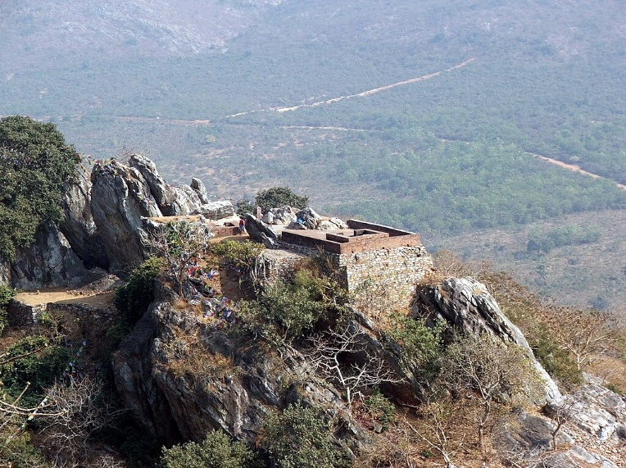

**Vulture Peak, Rajgir, India.** (The small structure (small room) designates the place where Buddha used to stay when living on Vulture Peak. This picture was taken from another, nearby mountain. The valley is where the outskirts of the old city of Rajagaha used to be). [7]

## **Wisdom at Gijjhakūṭa: A King’s Question, A Buddha’s Counsel**

(Based on DN:16 – Mahāparinibbāna Sutta)

### Introduction: When Power Meets Wisdom

In the days when Magadha flourished under King Ajātasattu’s rule, a moment of great significance took place atop Gijjhakūṭa, the Vultures’ Peak. The king, though mighty in worldly affairs, had tasted the Dhamma and begun to recognize the value of spiritual guidance. As he planned to wage war against the Vajjians—a confederacy across the Ganges—he turned not to his army, but to the Blessed One. What followed was not a command or permission, but a timeless teaching on the foundations of a flourishing society.

### The King’s Messenger

Wishing to act wisely, King Ajātasattu summoned his chief minister, the Brahmin Vassakāra, and instructed him:

“*Go to the Blessed Lord… and say: ‘Lord, King Ajātasattu of Magadha wishes to attack the Vajjians. Whatever the Lord declares to you, report that faithfully back to me, for Tathāgatas never lie.’”*

Respectfully, Vassakāra travelled from Rājagaha to Gijjhakūṭa, worshipped the Blessed One, and delivered the king’s message. At that moment, the Buddha did not respond directly to the prospect of war. Instead, with Venerable Ānanda by his side, he offered a teaching rich with insight.

### **The Seven Principles of Non-Decline**

Turning to Ānanda, the Buddha asked a series of questions about the Vajjians' conduct and customs:

- Do the Vajjians meet regularly and in harmony?

- Do they follow their ancient traditions?

- Do they respect their elders?

- Do they protect the virtue of women?

- Do they honour their shrines?

- Do they ensure safety for the Arahants and noble ones?

To each, Ānanda replied, “Yes, Lord.”  
  
The Blessed One then declared:

“*As long as the Vajjians uphold these principles, they may be expected to prosper and not decline.”*

He added that he had once taught these very principles to the Vajjians at the Sārandada Shrine in Vesālī. (see section 15-1)

### **The Buddha’s Silent Counsel**

Though the Buddha never directly told the king not to attack, his message was clear. Strength is not built through conquest, but through harmony, virtue, and wise governance. The true power of a nation—or a community—lies in its commitment to Dhamma.

### **Reflections: Lessons for Our Time**

This discourse from Gijjhakūṭa remains deeply relevant today. Whether in families, communities, or countries, the seven principles of non-decline remind us that lasting well-being arises from moral integrity, respect, and unity. Even a king, stirred by worldly ambition, paused to hear the voice of the Dhamma.  
May we, too, look to such wisdom in moments of decision, and may the light of the Blessed One continue to guide all who seek the path of peace.

## Significant Teachings to the Sangha: Factors of Non-Decline (Aparihāniyā Dhamma)

While dwelling at Gijjhakūṭa, the Blessed One, out of boundless compassion for his disciples, delivered a timeless teaching—guiding the Sangha on how to remain steadfast and flourish on the Noble Path.[8]

### Seven Factors Conducive to Welfare

The Buddha declared that as long as the monks:

1. Hold regular and frequent assemblies,
2. Meet and conduct their affairs in harmony,
3. Uphold the Vinaya without introducing unauthorized changes,
4. Honor and respect their elders in the holy life,
5. Guard themselves against sensual craving,
6. Are devoted to forest dwellings, and
7. Maintain mindfulness, welcoming the good and being a refuge to others—

They can be expected to prosper and not decline.

### Further Safeguards for Spiritual Welfare

He further encouraged the Sangha to cultivate Seven Inner Qualities That Sustain the Path

* Unwavering **faith** (saddhā),
* Humble **modesty** (hirī),
* Fear of wrongdoing (**ottappa**),
* **Dhamma learning**,
* Energetic **vigour** (viriya),
* Steady **mindfulness** (sati), and
* Penetrative **wisdom** (paññā).

### Foundations for Harmony and Communal Strength

The Buddha also emphasized six qualities that preserve communal harmony:

* Radiating loving-kindness in body, speech, and thought, both publicly and privately,
* Sharing righteously gained offerings with fellow virtuous monks,
* Keeping to unbroken, liberating discipline cherished by the wise,
* Remaining steadfast in such discipline with others,
* Upholding the noble view that leads to liberation,
* Maintaining that view together with one’s companions, in public and in private.

These six practices would uphold unity in the monastic community

### Further Deepening the Path

He urged the cultivation of the **Seven Factors of Enlightenment (Bojjhaṅgas)** and the **Seven Perceptions**: of impermanence, non-self, impurity, danger, overcoming, dispassion, and cessation.

These teachings are a timeless light for the Sangha—a safeguard, a compass, and a source of inner strength for those who walk the path of Dhamma. The teachings, rich with compassion and clarity, continue to serve as the foundation for the Sangha’s welfare. They are a legacy of wisdom, offering both protection from decline and a clear path toward liberation.

## Departing from Gijjhakūṭa: The Beginning of the Final Journey North

Although we earlier noted that the first phase of the Blessed One’s final journey began in Sāvatthi—the very cradle of Buddhism—ending in Rājagaha, the city where countless teachings were delivered and where the late King Bimbisāra and his followers became devoted supporters of the Buddha and the Saṅgha, the *Mahāparinibbāna Sutta* (DN 16) marks a deeper and more poignant transition.

According to this revered discourse, the ultimate and sacred journey toward the *Mahāparinibbāna*—the Great Passing Away—begins not in Sāvatthi, but at Gijjhakūṭa (Vulture’s Peak), one of the most cherished places where the Blessed One often stayed and shared profound Dhamma teachings with his disciples.

The Sutta records:

“And when the Lord had stayed at Rājagaha as long as he wished, he said to the Venerable Ānanda: ‘*Come, Ānanda, let us go to Ambalaṭṭhikā.’*  
‘*Very good, Lord,’ said Ānanda,* and the Lord went there with a large company of monks.”

With these simple, gentle words begins the second and final phase of the Tathāgata’s earthly journey—a journey that would ultimately lead to the serene grove of Kusinārā, the capital of the Malla Republic, where his body would find its final resting place beneath the twin sāla trees.

To guide our reflection and visualization of this profound path, we refer to the detailed map created by the distinguished Buddhist scholar Bhikkhu Ānandajoti, presented below. It traces the sacred route the Buddha and his Saṅgha followed, as recorded in the *Mahāparinibbāna Sutta*.

Before we recount this deeply moving journey, we offer the following words from the late Sister Vajira, a devoted and insightful Buddhist nun, whose reflections capture the essence of the Buddha’s final days:

*“…At the end of his life, after almost half a century’s ministry, the Master had long since taught all that was necessary for attaining the ideal. During the last period his primary concern, therefore, was to impress on his followers the necessity of unflinchingly putting into practice those very same teachings: an appeal that could, of course, hardly fail in stirring their hearts more than ever befor*e.” [9]

### The Sacred Route

From Rājagaha, the Blessed One journeyed northward to Ambalaṭṭhikā, then to Nāḷandā, and onward to Pātaligāma, where he crossed the Ganges River. From there, he continued to Koṭigāma, then to Nādikā, and reached Vesālī—the capital of the Vajji republic.

After spending time at the village of Beluva, where he observed his final vassa, the journey resumed. The Saṅgha moved onward to Bhaṇḍagāma, then to Bhoga-nagara, to Pāvā, and finally, to Kusinārā—where the last chapter of the Buddha’s physical life was written with the profound silence of awakening.

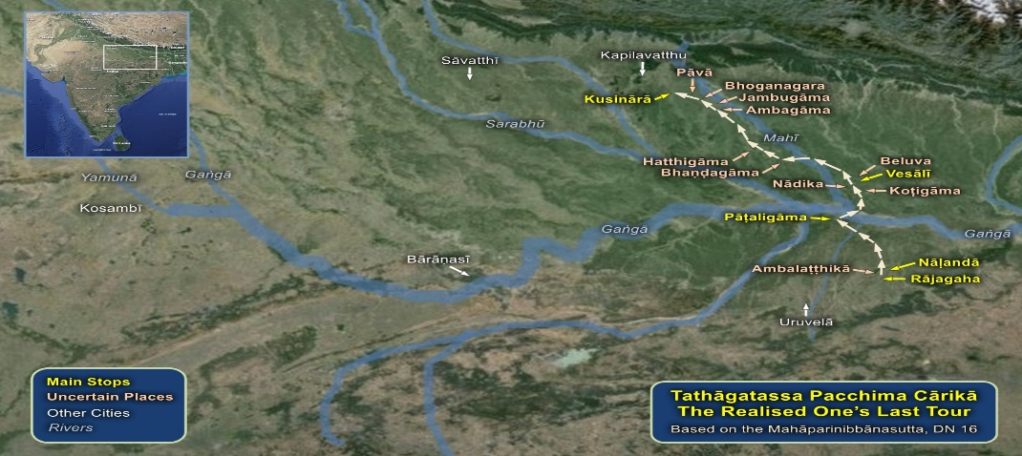

**Phase 2: the Final journey from Rājagaha to Kusninara [10]**

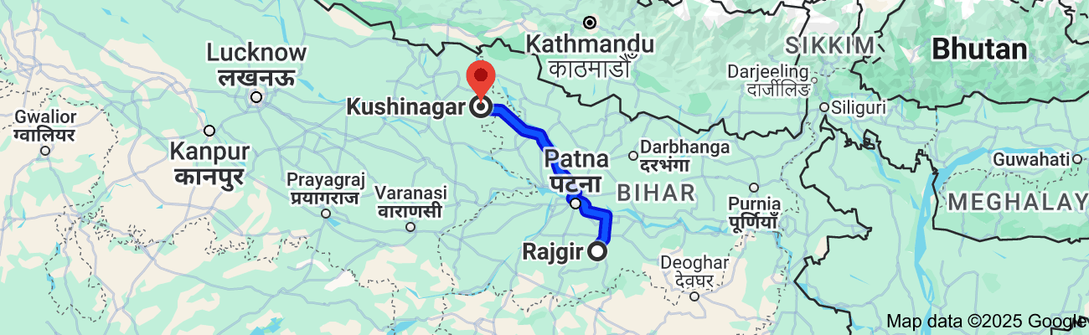

**Present-day map showing the distance from Rajgir to Kushinagar, about 314 km. In his final journey the Buddha and the Sangha may have walked about 26 yojanas [11] (see the maps below)**

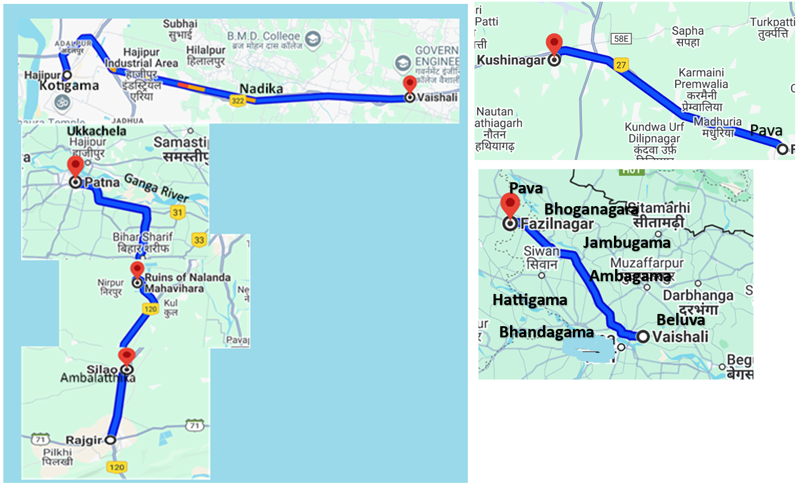

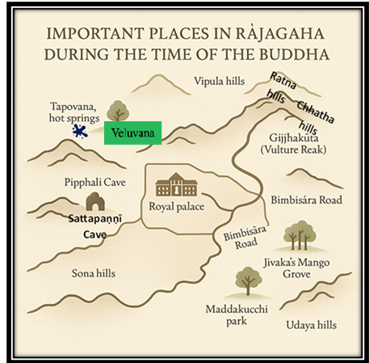

**Ancient Rājagaha city [12]**

## Important Places in Rājagaha during the Time of the Buddha

Before tracing the Blessed One’s journeys beyond the walls of Rājagaha, let us pause to contemplate the sacred sites within this ancient capital—places forever illumined by the presence of the Buddha and sanctified by his boundless compassion. These sites continue to inspire reverence in the hearts of pilgrims from across the world, who walk upon this soil to feel the spiritual legacy left behind not only by the touch of his feet, but by the luminous teachings he shared for generations to come.

Above is a sketch of the ancient city of Rājagaha, highlighting key landmarks associated with the life of the Buddha.

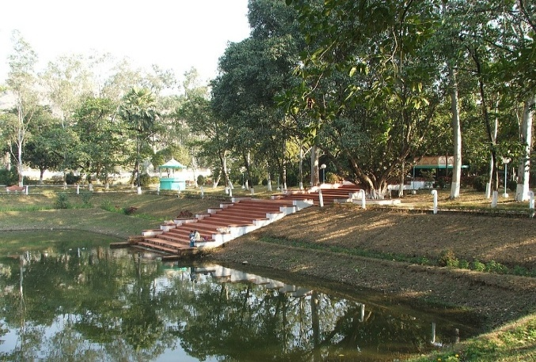

**Present day picture of ancient Veluvana monastery located beside the lake where the Buddha and the monks bathed.[13]**

### Veluvana Monastery (Bamboo Grove)

Nestled not too far, yet not too near, from the palace of King Bimbisāra, Veluvana was the first monastery ever donated to the Blessed One and the Sangha. It became a cherished sanctuary for both monastics and lay followers. A careful reading of the scriptures reveals that many profound discourses were delivered here—gems of wisdom offered for the welfare and liberation of all beings. Even today, modern-day visitors gather here with devotion, paying homage to this ground made sacred by countless footsteps of awakened ones. (See Section 14.1 for further details.)

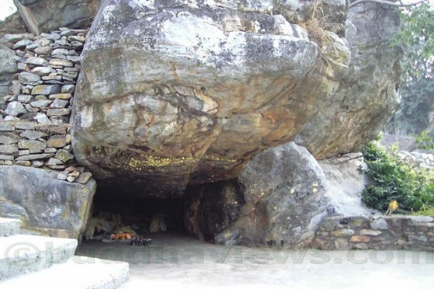

**A cave in Gijjakuta [14]**

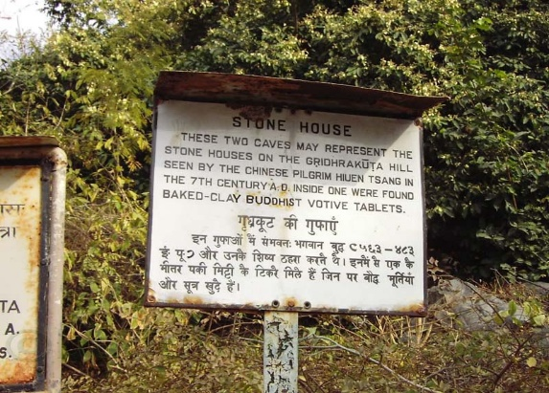

**Information of the location [15]**

### Gijjhakūṭa (Vulture Peak)

This serene mountain served as a frequent residence for the Buddha and his disciples during their stays in Rājagaha. Many of the most profound teachings in the Sutta Piṭaka were delivered here, including discourses that still echo with timeless wisdom. The Buddha’s final journey to Kusinārā is said to have commenced from this very place. Today, pilgrims ascend its rocky path, yearning not just to see the view, but to feel the compassionate vibrations of the Teacher who once walked there in silence and clarity.

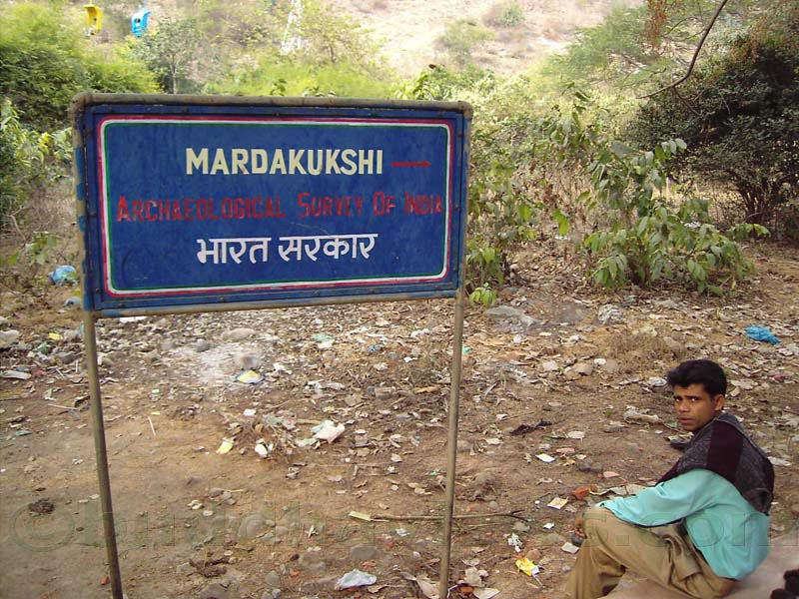

**Way to Ancinet Maddakucchi Royal Park [16]**

### Maddakucchi Royal Park

Situated at the foot of Gijjhakūṭa, this deer park was once a peaceful retreat where wild creatures roamed safely. This was one of the pleasure gardens of King Bimbisara. [17]It is remembered in the texts as the place to which the Buddha was taken after he suffered an injury caused by a rock dislodged by Venerable Devadatta. Weakened from blood loss, the Buddha was brought here by the monks, before being carried to the Jīvaka-ambavana for treatment. The park today stands as a reminder of the Buddha’s human vulnerability, met with the boundless care of his monks.

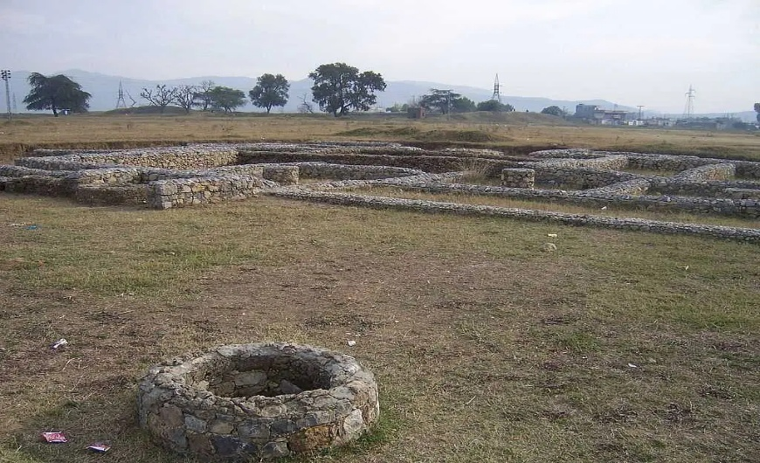

**Present day picture of Jivaka’s Mango Grove with the remains of the monastery where the Buddha and the Sangha dwelled when they were in Rājagaha [18]**

### Jīvaka’s Mango Grove

A lush, fragrant grove donated by the renowned physician Jīvaka, this was not only a place of rest but one of healing and heartfelt devotion. Jīvaka, a deeply devoted lay follower, built a monastery here where the Buddha and the Sangha could reside in comfort. His care for the Buddha, recorded vividly in the Vinaya Piṭaka, speaks volumes of his humility and compassion. Pilgrims still feel the spirit of loving service that pervades this gentle grove.

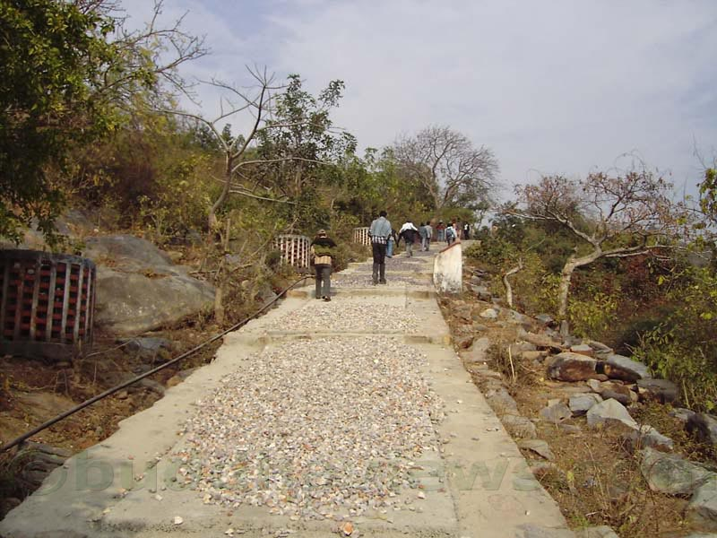

**Walking along the Bimbisāra road towards Gijjakuta[19]**

### Bimbisāra Road

Tradition tells us that King Bimbisāra constructed this road to visit the Buddha while he stayed at Gijjhakūṭa. Once about 20 feet wide, the road begins at the base of the hill and winds upward toward the sacred peak. Today, countless devotees retrace this path with reverence in their hearts. Although King Bimbisāra is no longer in this world, according to the Janavasabha Sutta (DN:18), he was reborn in the deva realms as a stream-enterer. Perhaps he watches from above, rejoicing to see the devotion of those who come to honour the Blessed One in his former kingdom.

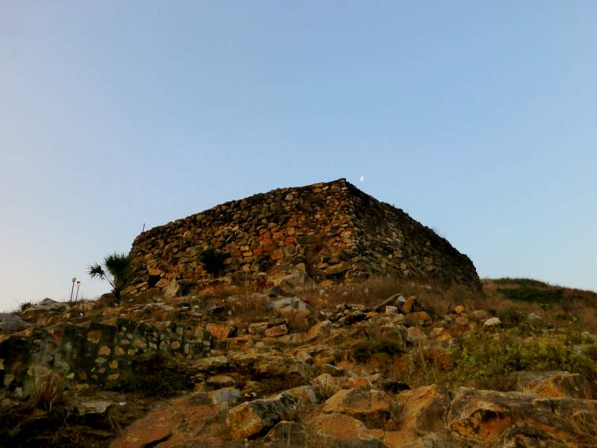

**Pipphali Cave, which was a favourite abode of Mahākassapa [20]**

### Pipphalī Cave

This cave on the Vebhāra Hills became a favoured dwelling of the great Venerable Mahā Kassapa. On one occasion, gravely ill, he was visited by the Blessed One, who lovingly recited the Bojjhaṅga Sutta. The healing power of Dhamma restored the elder’s strength. Even now, the cave seems to echo with those ancient verses, as though the compassion and serenity of that encounter still linger on its stone walls.

### Sattapaṇṇī Cave (Saptaparni Guha)

Also located on Vebhāra Hills, this cave holds immense historical and spiritual significance. It is the site where the First Buddhist Council was held following the Parinibbāna of the Buddha. According to the Mahāparinibbāna Sutta (DN 16), the Buddha once stayed here as well. For modern-day pilgrims, it is a place to reflect on the enduring legacy of the Dhamma and to feel, perhaps, the loving presence of the Teacher who foresaw the needs of future generations.

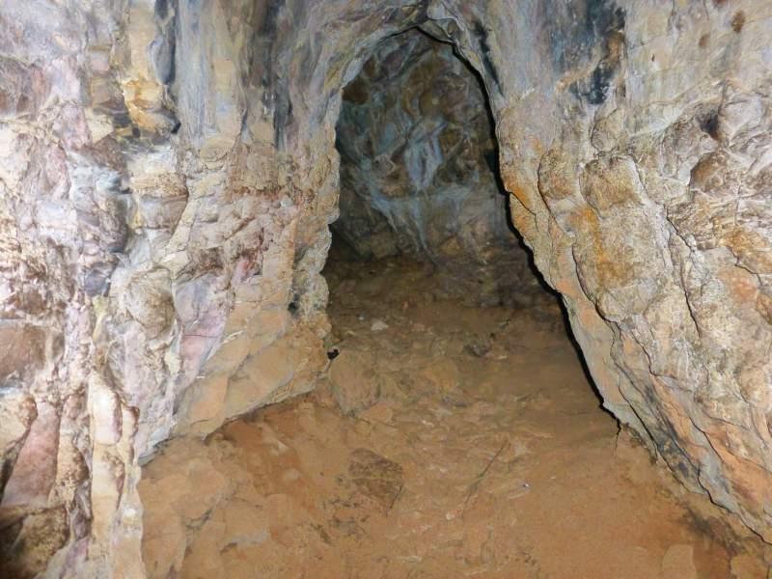

**Saptparni Cave [21]**

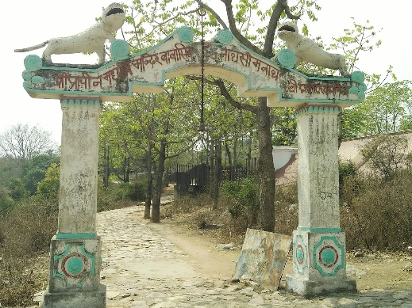

**Entrance to the Saptparni Cave [22]**

### Tapovana – The Hot Springs of Rājagaha

At the base of Vebhāra Hills lie the hot springs of Tapovana, where the Buddha and the Sangha are said to have bathed—not for ritual purification, but for the comfort of the body. Even today, both devotees and casual travellers pause to bathe in these healing waters. The springs remind us of the gentle humanity of the Buddha, who cared for the body not with attachment, but with wise attention.

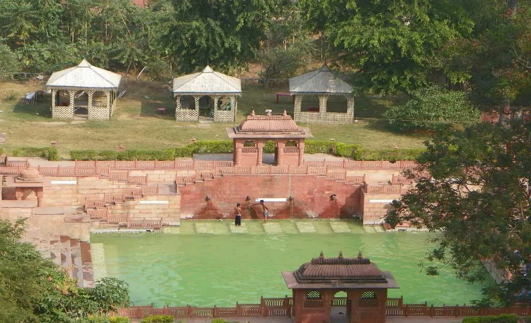

**Modern day picture of Tapovana, hot springs in Rajgir[23]**

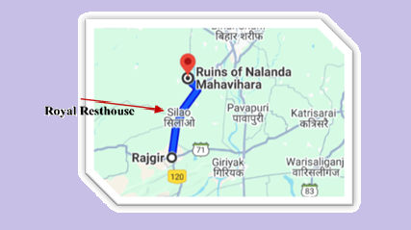

**Distance from Rajgir to Nalanda is about 15 km[24]**

## The First Stop at Ambalaṭṭhikā: A Place of Rest and Reflection

The modern map of India may not mark *Ambalaṭṭhikā*, yet ancient sources paint a vivid picture of its significance on the path between *Rājagaha* and *Nāḷandā*. Described as a royal park adorned with a rest-house (*rājāgāraka*), Ambalaṭṭhikā served as a cherished retreat where the Blessed One and his disciples often paused during their travels. [25] The place gained special prominence when the Buddha delivered the profound *Brahmajāla Sutta* (DN:1) here—an extraordinary teaching setting forth the broad net of views, and the path that leads beyond all of them.

The name *Ambalaṭṭhikā*, meaning “the Mango Sapling,” is said to have come from a young mango tree that stood near the park’s gate, offering shade and beauty. Protected by a rampart and adorned with artistic paintings for royal enjoyment, the site was more than a mere park—it was a sanctuary for stillness and insight. Later commentaries describe it not merely as a pleasance, but as a kind of *pāsāda*—a meditation hall (*padhānaghara*)—on the outskirts of *Veluvana Vihāra*, designed for those devoted to solitude and meditative striving.

It was here, at this quiet and inspiring place, that the Buddha delivered the *Ambalaṭṭhikā-Rāhulovāda Sutta* (MN:61) to his son, the young *Venerable Rāhula*, shortly after his ordination. In it, the Buddha gently taught the foundations of mindfulness and ethical reflection—teachings that would form the roots of Rāhula's spiritual growth.

According to the present-day geography, the town of *Silao*, located about 7–8 kilometres between *Rajgir* and *Nalanda*, may correspond to this ancient resting place. Though definitive archaeological evidence of Buddhist monuments has not yet emerged from the site, its strategic location on the ancient road strongly suggests that *Ambalaṭṭhikā* may have stood nearby. If so, this would have been the natural first stop for the Blessed One and the Sangha, as they made their northward journey—pausing here for rest, reflection, and Dhamma.

## The Final Teaching at Ambalaṭṭhikā: A Flame of Compassion

During his last journey, as recorded in the *Mahāparinibbāna Sutta* (DN 16), the Buddha again stayed at Ambalaṭṭhikā, and here he offered a deeply moving teaching—one that distils the essence of the path:

*“This is morality, this is concentration (Samadhi), this is wisdom.  
Morality, when fulfilled, brings great fruit and benefit.  
Concentration, when fulfilled, brings great fruit and benefit.  
Wisdom, when fulfilled, brings great fruit and benefit.  
The mind imbued with wisdom is fully liberated from the taints—  
the taint of sensuality, the taint of becoming, the taint of false views, and the taint of ignorance.”*

In these precious words, we glimpse the Buddha’s unwavering compassion. Though his body had grown old and frail, his heart remained vast and vibrant. Fully aware that time was short, he continued to nurture his disciples—urging them to deepen their practice, to contemplate, to strive with urgency. Many, including *Venerable Ānanda*, had not yet reached the final goal. And so, again and again, he emphasized the path: Sīla, Samādhi, Paññā—the threefold training that leads beyond sorrow, beyond bondage, to unshakable peace.

Even in the twilight of his life, the Buddha’s compassion burned like a steady lamp, lighting the way for those who followed him. He embodied the very message he gave: boundless love, clarity of vision, and tireless effort.

Having stayed at Ambalaṭṭhikā as long as he wished, the Master turned to Ānanda and said:

*"Let us go to Nāḷandā."*  
And so they continued northward—toward the next resting place on this final and sacred journey.

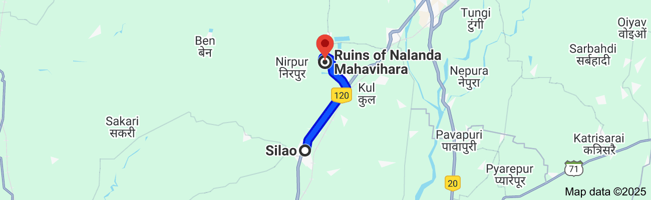

**Silao to Nalanda distance is about 8.7 km**

## Nāḷandā: The Ideal Second Stop

From the royal guesthouse at Ambalaṭṭhikā—likely near present-day Silao—the Blessed One continued his journey toward Nāḷandā, accompanied by a large community of bhikkhus. [26]

The distance was about 8.7 kilometres, or roughly 0.7 yojanas—a notably shorter stretch compared to the Buddha’s earlier travels, which often covered a full yojana per day. This gentle pace perhaps reflects the Blessed One’s physical decline with age, and the growing tenderness of those final months.

Upon arriving in Nāḷandā, the Buddha stayed in the mango grove of the devoted householder Pāvārika. This Pāvārika is distinct from the similarly named benefactor at Kosambī. The texts mention this grove several times as a resting place during the Buddha’s travels to and from Rājagaha (DN 11, DN 28, SN 47, SN 35), suggesting its role as a familiar and supportive sanctuary.

Although the great Nāḷandā Mahāvihāra—the renowned university—was established in later centuries, Nāḷandā was already a spiritually significant place in the Buddha’s time. Most notably, it was the birthplace and parinirvāṇa site of Venerable Sāriputta, the Blessed One’s chief disciple in wisdom. In later times, Emperor Asoka honoured Sāriputta by building a stupa enshrining his relics, which became a revered place of pilgrimage. [27]

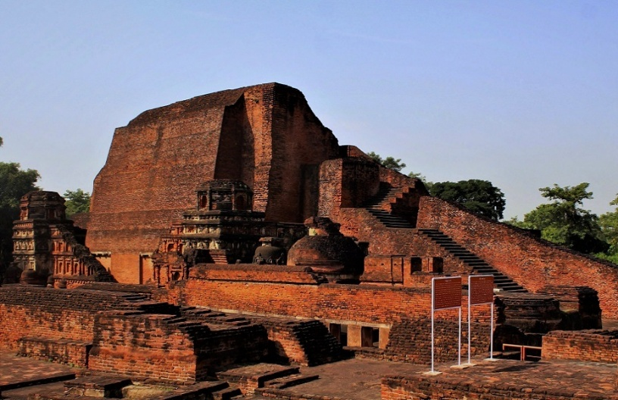

**Sāriputta stupa in Nālanda, Rajgir, Bihar [28]**

The Sariputra Stupa, is the most iconic of the surviving monuments at the Nalanda World Heritage Site. Built in the 3rd Century by Mauryan emperor Ashoka in the honour of Venerable Sariputra, the chief disciple of the Buddha who was born and attained Parinibbana in this same region.

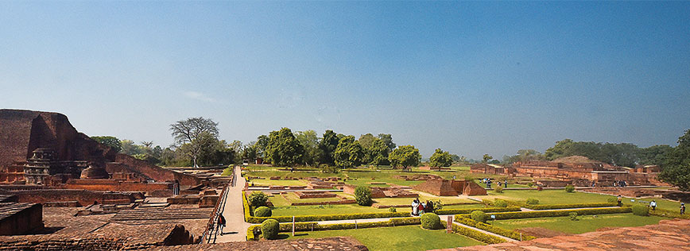

**The historic site of Nalanda with the Great Stupa on the left**

#### References to Nāḷandā in the Scriptures

The existence of Nāḷandā in ancient India is mentioned multiple times in Buddhist texts:

DN: 11 Kevaddha Sutta, DN:28 Sampasādanīya Sutta, SN42:9 Asibandhakaputta Sutta, headman, SN47: 12 Nālanda sutta SN35: 126 Nālanda sutta

## Profound Encounter with Venerable Sāriputta

During this stay, a profound exchange took place between the Buddha and Sāriputta. Approaching the Blessed One, Sāriputta offered a bold and heartfelt tribute: [29]

*“It is clear to me, Lord, that there never has been, never will be, and is not now another ascetic or Brahmin who is better or more enlightened than the Blessed One.”*

The Buddha responded with gentle inquiry:

“Sāriputta, have you seen the minds of all the Arahant Buddhas of the past?”  
“No, Lord.”  
“Have you seen those of the future?”  
“No, Lord.”  
“Do you know the full mind of the Tathāgata here and now?”  
“No, Lord.”

The Buddha asked whether this bold declaration was not, then, spoken too strongly. But Sāriputta humbly explained:

“Lord, while I do not know the minds of the Buddhas, I know the *drift* of the Dhamma. Just as a wise gatekeeper may not see every crack in the fortress wall, but knows that all who enter or leave the city must pass through the one main gate—so too, all Arahant Buddhas attain enlightenment by abandoning the five hindrances, firmly establishing the four foundations of mindfulness, and realizing the seven factors of enlightenment. This, Lord, is the gate through which they all pass.”

The Buddha rejoiced in this reply, praising Sāriputta’s insight:

*“Good, good, Sāriputta! Therefore, you should frequently share this Dhamma exposition with the bhikkhus and bhikkhunīs, with male and female lay followers. For even if some have perplexity or doubt about the Tathāgata, upon hearing this, their uncertainty will be resolved.”* [30]

In this way, Nāḷandā became more than a resting place—it became a stage for the lion’s roar of wisdom, spoken not in pride, but in deep faith and understanding.

### The Noble Transformation of Upāli: A Story of Sincere Inquiry and Spiritual Awakening

In *Majjhima Nikāya*  (56: Upāli Sutta), it is recorded that the Blessed One was residing at Nāḷandā in Pāvārika’s Mango Grove when Upāli, a wealthy householder and prominent supporter of Nigaṇṭha Nātaputta, visited him. Nigaṇṭha Nātaputta, too, was staying in Nāḷandā at that time with a large assembly of his own followers. Having listened to the Dhamma of the Blessed One, Upāli became established in faith, attained the state of a stream-enterer, and from then on became a devoted follower of the Buddha.

When news of Upāli’s conversion reached Nigaṇṭha Nātaputta, he lamented, *“You have been caught by the great net of the doctrine of the recluse Gotama… you have been converted by the recluse Gotama through his converting magic.”*

This remarkable story, though not mentioned in the *Mahāparinibbāna Sutta (DN:16)*, is traditionally accepted to have taken place during the Buddha’s final journey. There are several reasons to support this view:

1. **Location and Timing**  
   The *Upāli Sutta* clearly states that both the Buddha and Nigaṇṭha Nātaputta were residing in Nāḷandā at the time. According to the *Mahāparinibbāna Sutta*, the Blessed One did pass through Nāḷandā during his final journey toward Kusinārā, spending time there at Pāvārika’s Mango Grove.
2. **The Sudden Death of Nigaṇṭha Nātaputta**  
   At the conclusion of the *Upāli Sutta*, it is said that Nigaṇṭha Nātaputta was overwhelmed with distress upon hearing Upāli praise the Buddha. The commentary explains that due to intense grief at losing such a prominent lay supporter, he suffered a bodily disorder and vomited hot blood. He was then transported to Pāvā, where he soon passed away. Tradition holds that few beings survive such a condition, marking this as a significant and final episode in Nigaṇṭha Nātaputta’s life.
3. **Confirmation in the *Dīgha Nikāya***  
   In *Dīgha Nikāya 29* (*Pāsādika Sutta*), it is recorded that the novice Cunda, who had spent the rains at Pāvā, brought news of Nigaṇṭha Nātaputta’s death to Venerable Ānanda at Sāmāgāma. Ānanda then went with Cunda to inform the Buddha. While this sutta does not explicitly place the event during the Buddha’s final journey, the Buddha’s reflection in response strongly hints at his approaching final days:

“*But now, Cunda, I have appeared in the world as an Arahant, a Fully Enlightened One… But now I am an aged teacher of long standing, who went forth a long time ago, and my life is coming to its close*.” (*DN 29*)

1. **The Mysterious Village of Sāmāgāma**  
   The location of Sāmāgāma is not identified on modern maps, but other references provide clues. In *AN 6.21*, the Buddha is said to have stayed at “Sāmāgāmaka among the Sakyans, near the lotus pond.” The commentary confirms that both suttas refer to the same Sāmāgāma, suggesting that Sakyans inhabited this area within the Vajjian confederacy—possibly near Vesālī—where the Buddha also stayed during his final journey.

The presence of Sakyans in this region is further supported by the historical and geographical context. The Vajjian confederacy included the Licchavis of Vesālī and the Vedehis of Videha (to which King Ajātasattu’s mother belonged), with their capital at Mithilā. The Videha republic covered parts of present-day Bihar and southeastern Nepal. This suggests that, during his journey northward to Kusinārā, the Buddha may have deliberately visited areas inhabited by Sakyans for their benefit. (see the map below)

1. **Further Supporting Traditions**  
   The *Apadāna* commentary (ApA.i.106) offers a clue about the cultural interconnections of this region, mentioning that Venerable Ānanda was called “Vedehamuṇi” because his mother came from Videha, even though he was a Sakyan prince. This supports the idea of Sakyan-Videhan ties and helps explain the Buddha’s movement through these regions during his final journey.

**Conclusion:**  
While the *Mahāparinibbāna Sutta* does not specifically mention Upāli’s conversion, the timing, location, and related traditions strongly suggest that the *Upāli Sutta* was indeed delivered during the Buddha’s final journey. Therefore, we believe it is both meaningful and appropriate to include this interpretation in our publication—as a reasoned proposal supported by scriptural cross-references and traditional commentary, offered with humility and respect for the Dhamma.

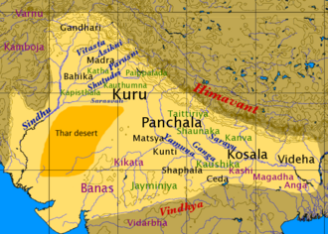

**Map showing the Location of Videha**[31]

### The Converting Magic of the Buddha

In the time of the Buddha, even the most confident opponents found themselves transformed by the power of truth. This is the story of Upāli, a wealthy lay disciple of the Nigaṇṭhas, who set out to defeat the Buddha in debate—but instead found the Dhamma.

At that time, the Nigaṇṭha Nātaputta was seated with a large assembly of laymen from Bālaka, headed by the householder Upāli. When the ascetic Dīgha Tapassī was seen approaching in the distance, Nātaputta asked:

*“Where are you coming from in the middle of the day, Tapassī?”*

*“Venerable sir, I have just come from the presence of the recluse Gotama.”*

*“Did you have a conversation with him?”*

*“Yes, venerable sir,”* Tapassī replied, and proceeded to relate his entire dialogue with the Blessed One.

Upon hearing this, Nātaputta exclaimed, “Well done, well done, Tapassī! You have responded like a well-instructed disciple who rightly understands his teacher’s doctrine. What is the trivial mental rod compared to the gross bodily rod? Indeed, it is the bodily rod that is most blameworthy in committing evil actions—not so much the verbal or mental rods.”

Hearing this, the householder Upāli agreed and declared:

“Well said, venerable sir, on the part of Tapassī! I, too, shall now go and refute the recluse Gotama’s doctrine on this very basis. If he upholds what Tapassī made him uphold, then I will out-debate him—just as a strong man might seize a long-haired ram by the hair and drag it to and fro. Just like a brewer’s worker throws a sieve into a water tank and stirs it in all directions, I will handle the recluse Gotama in debate the same way.”

Nātaputta approved: “Go, householder, and refute him. If not I, then Tapassī or you must refute the recluse Gotama.”

But Tapassī protested: “*Venerable sir, I do not agree that Upāli should go. For the recluse Gotama is a magician—he knows the art of converting others.”*

To this, Nātaputta proudly replied: “*It is impossible that the householder Upāli would become a disciple of Gotama. On the contrary, it is more likely that Gotama would become a disciple of Upāli!”*

#### The Encounter

Thus, Upāli departed to meet the Blessed One at Pāvārika’s Mango Grove. After paying homage, he asked:

*“Venerable sir, did Dīgha Tapassī visit you?”*

*“He did, householder.”*

*“And did you have a conversation with him?”*

*“We did, householder.”*

Then the Blessed One recounted the entire dialogue with Tapassī. Upon hearing it, Upāli praised Tapassī:

“*Well said, venerable sir! Tapassī answered like a faithful disciple. Truly, the bodily rod is the most reprehensible in performing evil, not the verbal or mental ones.”*

“Householder,” said the Blessed One, “if you wish to debate on the basis of truth, then let us proceed.”

“I shall debate on the basis of truth, venerable sir.”

### The Paradox of the Mind-Bound Gods

“Suppose a Nigaṇṭha is gravely ill. His vows forbid cold water, yet he longs for it mentally and uses only hot water. He dies without fulfilling his desire. Where would Nātaputta say he is reborn?”

“In the realm of the 'mind-bound' gods, venerable sir. Because his mind remained attached.”

“Householder, pay attention to your answers. What you said now contradicts what you said earlier, and what you said earlier does not agree with what you say now. Yet you claimed, ‘I will debate on the basis of truth.’”

Despite this, Upāli persisted: “Still, I say the bodily rod is the most reprehensible.”

### The Hidden Destruction

“What if a Nigaṇṭha is restrained in all four ways—yet when he walks, he unintentionally kills many small beings. What does your teacher say about that?”

“If unintended, it is not greatly blameworthy.”

“But if it is intended?”

“Then it is, venerable sir.”

“Under which rod is volition placed?”

“Under the mental rod, venerable sir.”

“Householder, again your words contradict themselves.”

Even so, Upāli insisted: “Still, the bodily rod is the most harmful.”

### The Similes of Nāḷandā

“Is Nāḷandā a thriving and populous town?”

“Yes, venerable sir.”

“If a man with a sword said: ‘In a single moment I will make all living beings in Nāḷandā a mass of flesh,’ would he succeed?”

“No, not even fifty men could do that!”

“But what if a recluse with supernormal power declared: ‘With a single thought of hate, I shall reduce this city to ashes’—could he do it?”

“Yes, venerable sir, he could destroy many Nāḷandās with one thought.”

“Then, householder, which is more potent—the bodily or the mental rod?”

Again, the contradiction in Upāli’s statements was pointed out. Yet he confessed:

“Venerable sir, I was already won over by your very first simile. But I wished to hear your varied solutions. Magnificent, venerable sir! You have made the Dhamma clear in many ways—as if turning upright what had been overturned, revealing what was hidden, or holding up a lamp in the dark for those with eyes to see. I go for refuge to the Blessed One, the Dhamma, and the Sangha. Let the Blessed One remember me as a lay follower for life.”

### The Buddha’s Gentle Encouragement

The Blessed One replied gently:

“Investigate thoroughly, householder. It is fitting for well-known people such as yourself to examine thoroughly.”

Upāli was even more pleased: “Venerable sir, I am deeply moved that you did not seek to claim me, but encouraged me to examine the truth. Others would proclaim it proudly, but you, venerable sir, are truly free of conceit.”

And again, he declared: “For the second time, I go for refuge…”

Then the Blessed One said, “Your family has long supported the Nigaṇṭhas. When they come, you should still give alms.”

To which Upāli replied: “Even more do I rejoice, venerable sir. I had heard others claim you say: ‘Gifts should only be given to me and my disciples.’ But you have encouraged generosity to others. Still, we shall know when the time is right. So, for the third time, I go to the Blessed One for refuge…”

The episode of **Upāli's conversion** beautifully showcases the *compassionate skilfulness* and *transformative wisdom* of the Blessed One. The Dhamma welcomes sincere inquiry. Transformation arises not by force, but through understanding. Even great opponents can become faithful followers. The mental volition is deeper than bodily action. The Buddha discouraged blind allegiance, even when someone converted. The Blessed One’s wisdom lies not in conquering others—but in illuminating the path to truth!

### Praising the Blessed One

Grateful to the Teacher who gently guided him onto the noble path, and having abandoned wrong views to become firmly established in unwavering faith, the householder Upāli extolled the Blessed One in verses filled with deep admiration and insight. He exclaimed:

*“Suppose there were a great heap of many kinds of flowers, and then a clever garland-maker were to weave them into a multicoloured garland — so too, the Blessed One possesses many praiseworthy qualities, hundreds upon hundreds of them. Who would not praise the praiseworthy?”[32]*

To uplift and inspire our readers, we have selected a few of these luminous verses:

**He is free from doubt and skilful,**  
*the discipliner and excellent leader.*  
*None can surpass his resplendent qualities;*  
*without hesitation, he is the illuminator;*  
*Having severed conceit, he is the hero:*  
**The Blessed One is he, and I am his disciple.**

**The leader of the herd, he cannot be measured,**  
*his depths are unfathomed, he attained to the silence;*  
*Provider of safety, possessor of knowledge,*  
*he stands in the Dhamma, inwardly restrained;*  
*Having overcome all bondage, he is liberated:*  
**The Blessed One is he, and I am his disciple.**

**The immaculate tusker, living in remoteness,**  
*with fetters all shattered, fully freed;*  
*Skilled in discussion, imbued with wisdom,*  
*his banner lowered; he no longer lusts;*  
*Having tamed himself, he no more proliferates:*  
**The Blessed One is he, and I am his disciple.**

**The best of seers, with no deceptive schemes,**  
*gained the triple knowledge, attained to holiness;*  
*His heart cleansed, a master of discourse,*  
*he lives ever tranquil, the finder of knowledge;*  
*The first of all givers, he is ever capable:*  
**The Blessed One is he, and I am his disciple.**

With these radiant verses, echoing the heartfelt devotion of Upāli, we conclude this section.

The next part (19.3) will explore the profound and significant events that unfolded during the remainder of the Blessed One’s final journey.

### End Notes: Section 19-2

1. Map source: https://www.shutterstock.com/image-vector/blank-ancient-map-on-old-parchment-1006789423
2. Image created by AI.
3. These inspiring poems dedicated to the Blessed One by a dear Kalyana mitta.
4. DN16 (Mahāparinibbāna Sutta)
5. Image created by AI
6. https://en.wikipedia.org/wiki/Vulture_Peak
7. Ibid.
8. DN16 (Mahāparinibbāna Sutta)
9. Source: Last Days of the Buddha: Mahāparinibbāna Sutta: Wheel 67/68, BPS.
10. Source: https://ancient-buddhist-texts.net/Maps/During-Buddhas-Time/Map-05-Last-Tour.htm
11. Google Map * Converting table source: https://www.unitsmash.com/converters/length/kilometer/to/yojana/314
12. Map created by AI.
13. Source: https://commons.wikimedia.org/wiki/File:Venuvana.jp
14. Source: https://www.buddhaviews.com/Buddha_India/buddha_india301.htm
15. Ibid.
16. Ibid.
17. Source: https://www.aimwell.org/DPPN/maddakucchi.html
18. Source: https://www.holidify.com/places/rajgir/jivakas-mango-garden-sightseeing-122417.html
19. Source: https://www.buddhaviews.com/Buddha_India/buddha_india301.htm
20. Source: https://photodharma.net/India/Rajgir/index.htm
21. Ibid.
22. Source: https://www.reddit.com/r/Buddhism/comments/133friu/saptaparni_cave_the_site_where_the_first_buddhist/?rdt=61227
23. Source: https://www.avathi.com/place/rajgir-s-sacred-hot-springs/8263
24. Google map.
25. Source: https://www.palikanon.com/english/pali_names/am/ambalatthikaa.htm
26. DN:16.
27. Source: Wikipedia https://en.wikipedia.org/wiki/Nalanda_mahavihara#:~:text=Sariputta%2C%20a%20prominent%20disciple%20of,stupas%20at%20Sanchi%20and%20Mathura.
28. https://www.trawell.in/bihar/nalanda/sariputra-stupa-great-stupa
29. DN:16. * the same statement was made by Venerable Sāriputta in SN47: 12 Nalanda sutta.
30. See: SN: Note: 156: This conclusion also comes at the end of DN No. 28, at DN III 116, following the much more effusive praise of the Buddha found there.
31. https://en.wikipedia.org/wiki/Videha#/media/File:Map_of_Vedic_India.png
32. MN:56